SyncSharp: Plug & Sync

File Synchronization Software

User Guide V1.0

***3/30/2010***

***Azhar Bin Mohamed Yasin***

***Loh Jianxiong Christopher***

***Hong Lei***

***Guo Jiayuan***

***Tian Shuang***

***Tan Yewkang***

**TABLE OF CONTENTS**

***Part 1 Product Description 03***

***Part 2 Using SyncSharp 03***

***2.1 On First Run 03***

***2.2 Creating New Sync Task 04***

***2.3 Delete Sync Task 05***

***2.4 Modifying Sync Task 05***

***2.5 Task Management Menu 11***

***2.6 Import Sync Task 12***

***2.7 Export Sync Task 12***

***2.8 PlugSync*  *13***

***2.9 Configuring Global Settings 14***

***Part 3 Troubleshooting 15***

***3.1 Auto-Play feature Is Not Working 15***

***Part 4 Glossary 17***

**Part 1: Product Description**

Syncsharp is developed for users who work with multiple computers and need to synchronize files that reside in different computers through an immediate device such as a USB drive. It is a Windows based application that allows users to sync files between multiple computers through an immediate device with no installation required. The file synchronization process is streamlined through a list of pre-determined user preferences.

**Part 2: Using Syncsharp**

2.1 On First Run

On first run, user will need to run SyncSharp manually by double clicking on the program executable. Subsequently, the program will launch automatically upon USB device plug-in. Upon double clicking the executable, the following main window will pop up.

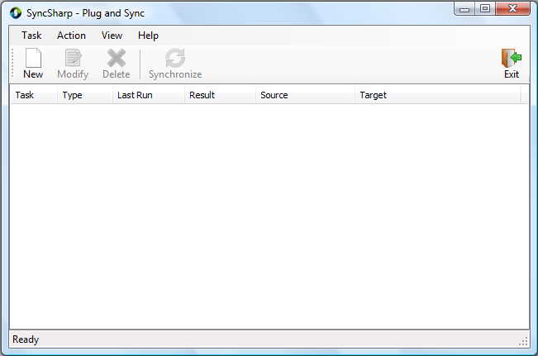

2.2 Creating New Sync Task

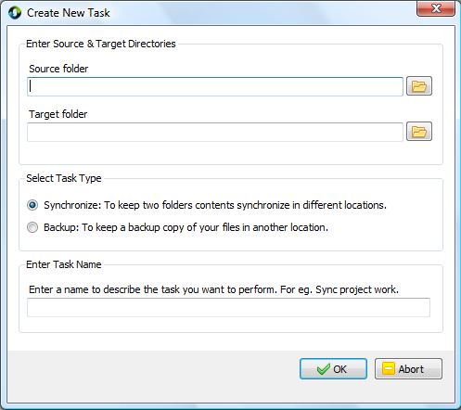

*Step 1:* Click on ***New***, the ***Create New Task*** window will show up.

*Step 2:* Click on the browse icon  to select the two source and target folders.

*Step 3:* ***Select Task Type***.

Synchronize – To keep source and target folders contents in sync.

Backup – To backup files in source folder to target folder.

*Step 4:* ***Enter Task Name***. Specify the name of this Sync Task. (This task will be saved, so next time the program is activated. It will automatically try to complete this task)

*Step 5:* Click on ***OK*** to finish the wizard.

2.3 Delete Sync Task

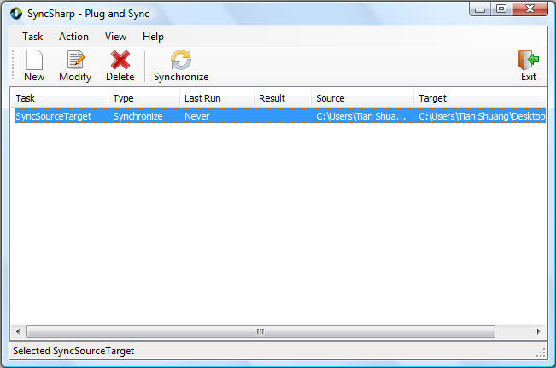

*Step 1:* Choose the Sync Task you want to delete.

*Step 2:* Click ***Delete***.

2.4 Modify Sync Task

*Step 1:* Click on the Sync Task you want to delete.

*Step 2:* Click ***Modify***. The ***Task Setup*** window will pop up. It consists of 4 tabs.

* ***General*** – Display general information.
* ***Folder Pair*** – Modify folder pairs.
* ***Filter*** – Include/exclude file/folders in sync action.
* ***Advanced*** – Advanced syncing options.

***General*** Tab

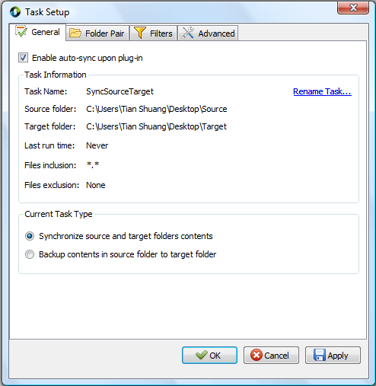

***Enable auto-sync upon plug-in*** – With this option checked, task will be synchronized automatically when the program is executed on next run.

***Folder Pair*** Tab

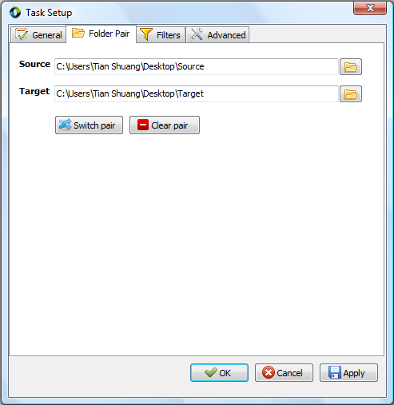

***Switch pair*** – Switch the path of “Source” and “Target”

***Clear pair*** – Delete the path of “Source” and “Target”

***Filters*** Tab

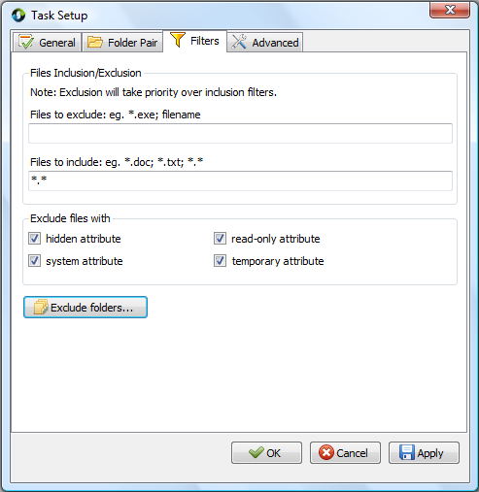

***File Inclusion/Exclusion*** - Users are allowed to include/exclude files in “source” and “target” directory in the sync process. Filtering is based on file name or extension, (For e.g., to exclude all files with extension ‘***.doc***’, put ‘***\*.doc***’ in ‘***Files to exclude***’ textbox). Users is allowed to set multiple filtering criteria separated by ‘***;***’.

Filtering of subfolders is achieved by using the ***Exclude folder…*** option***.***

***Exclude files with*** – Filtering can also be achieved based files/folders attributes. The default files to exclude are files with ‘***system***’ and ‘***temporary***’ attribute.

***Exclude folders…*** will list out all sub folders in “Source” and “Target”. User is able to exclude sub-folders by checking the respective folders. (Below is a screenshot of its window).

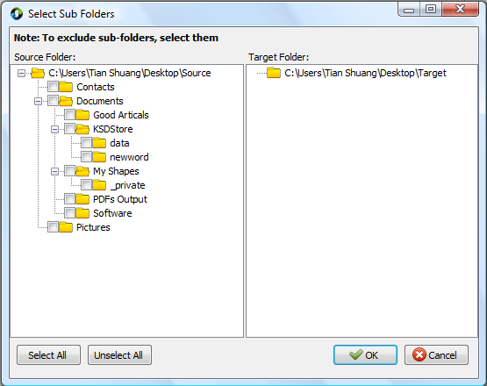

***Advanced*** Tab

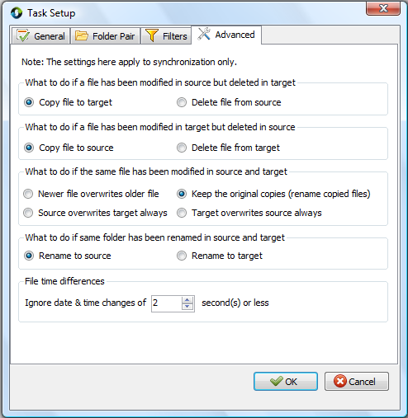

***File time differences*** – While comparing two files or folders, if the difference in last-modified-time is less than or equals to the pre-set value. These files or folders are considered to be with the same modification time.

2.5 Task Management Menu

On the main window, right clicking on any task will bring up the ***Task Management Menu*** (as shown below). User can modify, delete, rename, synchronize, view log file or create new task using the menu.

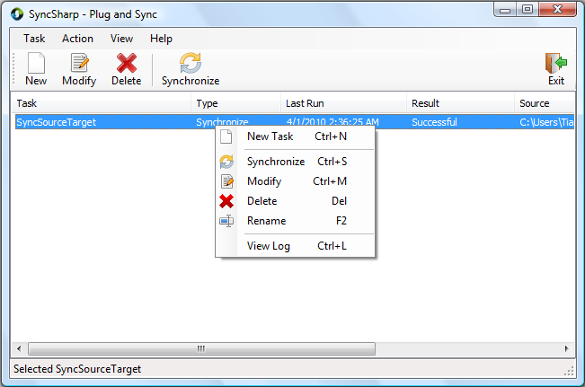

***View Log*** provides a summary of last synchronization to user. Things like which files/folders are copied over from source to target, what kind of conflicts are resolved, which files have been deleted, etc, will be listed as ***FILE ACTION*** or ***FOLDER ACTION*** in the log. A sample log file is shown below.

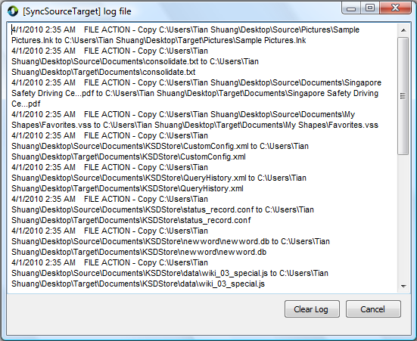

2.6 Import Sync Task

*Step 1*: On the main menu, click ***Task***

*Step 2*: Click ***Import All Task …*** or simply use ***Ctrl + I***

*Step 3*: Specify which SyncTask to import.

2.7 Export Sync Task

*Step1*: On the main menu, click ***Task***

*Step 2*: Click ***Export All Task …*** or simply use ***Ctrl + E***

*Step 3*: Specify the location you want the SyncTask to be saved.

2.8 PlugSync

The **PlugSync** window as shown below will be displayed if user has previously setup tasks (auto-sync enabled) in Syncsharp when the program is launched. The window will start to count down for 5 seconds (default) before synchronizing the tasks listed in the window.

User can return back to main window by clicking on the  button. Moreover, user can re-order the tasks to be synced by clicking the up and down buttons. User can also remove a task from the window if it is not synchronized yet.

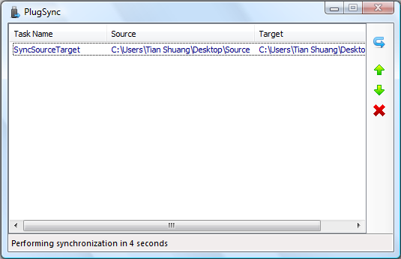

2.9 Configuring Global Settings

*Step1*: On the main menu, click ***View***

*Step 2*: Click on ***Options …***, the ***Global Settings*** window shown as below will pop up

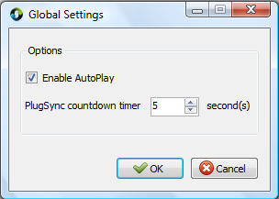

*Step 3*: Use the up and down arrow to change the default countdown timer. (Sync will start right away if the timer was set to 0.)

***Enable AutoPlay.*** If checked, an ***autorun.inf*** will be created on the external storage device to auto launch SyncSharp upon plug in to PC.

**Part 3 Troubleshooting**

3.1 Auto-Play feature Is Not Working

On some Windows machines, ***auto play*** feature may be disabled. So in order to fully automate the synchronization process using ***PlugSync***, user may need to modify the ***auto play*** settings. This guide will walk you through step by step on how to change the ‘auto play’ settings.

On Windows Vista:

*Step 1*: Click on ***Start*** 🡪 In the search box, type in ***autoplay***

*Step 2*: Choose the first returned result, which looks like



*Step 3*: Click on the icon, the following window will pop up.

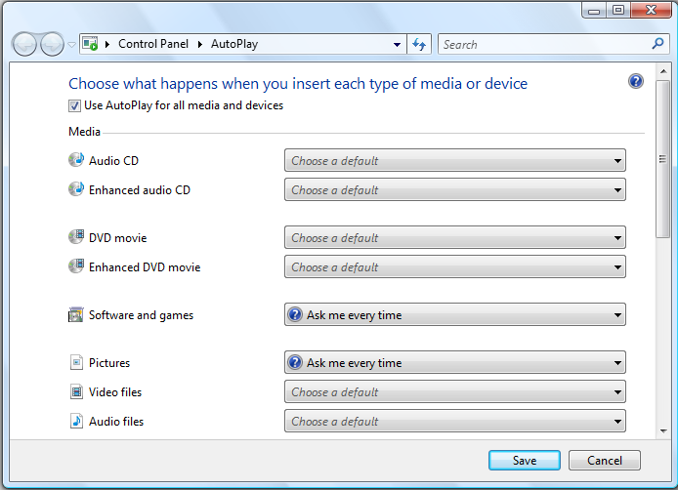

*Step 4*: Check the box ***Use AutoPlay for all media and devices***

*Step 5*: In the drop-down list for ***Software and games***, choose ***Ask me every time***.

*Step 6*: Click on ‘***Save***’ to save the setting.

*Step 7*: The next time user plug in his external storage device, system will prompt user for actions. A window looks like the following will show. Check the box ‘***Always do this for software and games:***’ and click on ‘***Run SyncSharp***’ to activate the program. By doing this, this action is saved on the machine, and the PlugSync feature will function properly.

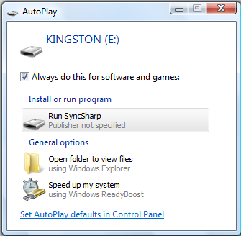

**Part 4 Glossary**

|  |  |
| --- | --- |
| Term | Definition |
| SyncSharp | Name of our sync tool |
| SyncTask | Configuration file that contains source and target directory information to be synchronized |
| SyncProfile | Contains list of SyncTasks for a Particular PC/Laptop |
| FileUnit | Abstract representation of a file or folder, contains information such as name, size, hash code, last modified date, etc. |
| PlugSync | A feature of our program. Program will synchronize all tasks automatically when the USB device is plugged into a computer. Upon execution, the program will count down for 5 seconds waiting for user interruption. If there is no interruption, the program will proceed to synchronize all the tasks listed in the window. |
| 1 way sync | Update destination directory to have the same content as source directory |
| 2 ways sync | Update source and destination directories to have the same state |
| Report/Logger | Log file that records the operations perform in the synchronization process |
| Target | The destination directory to be sync or compared |
| Detector | The sub-system that detect changes of the source or destination directory |
| Reconciler | The sub-system that resolves conflicts between the source & destination directories |
| TaskSettings | Contains configuration settings made for each SyncTask |